NAME: | PARVENDHAN C
ROLL NO: | 2418011197
DEPARTMENT: | AI&DS
- Write a query to display the last name, department number, and department name for all
employees.
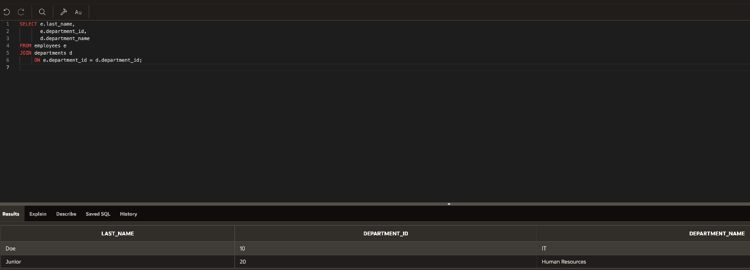
- Create a unique listing of all jobs that are in department 80. Include the location of the department
in the output.
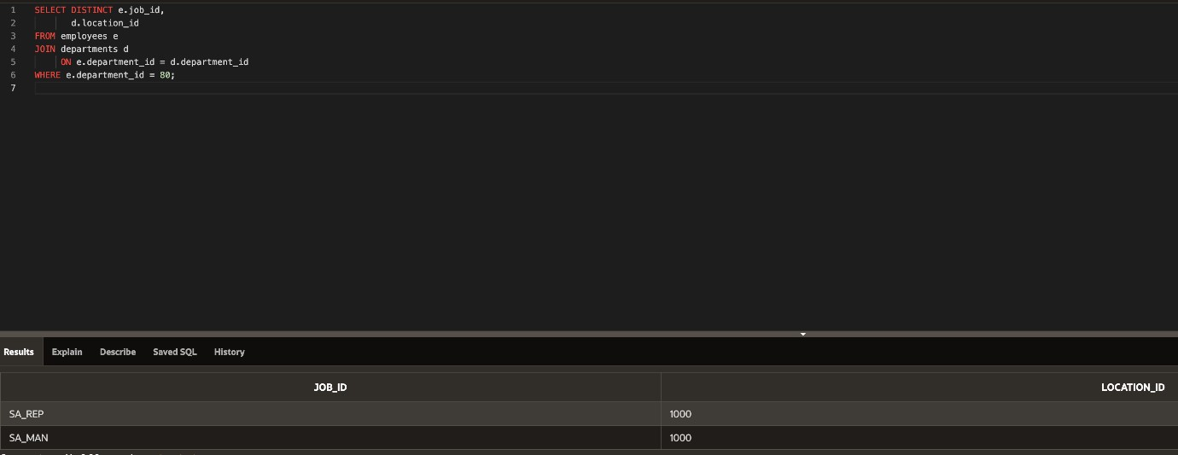
- Write a query to display the employee last name, department name, location ID, and city of all employees who earn a commission
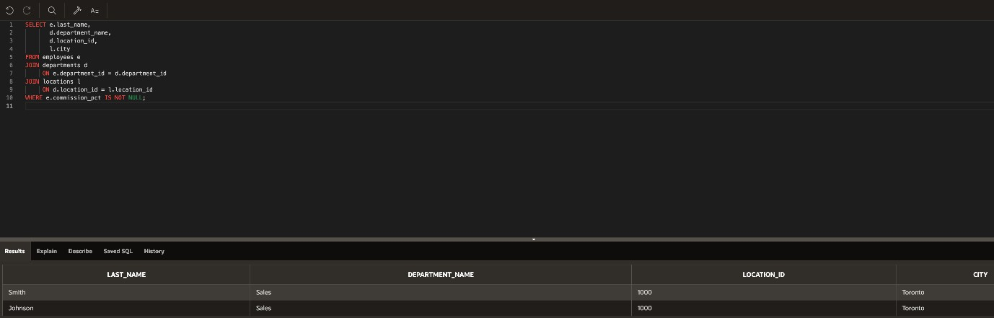
- Display the employee last name and department name for all employees who have an a(lowercase) in their last names.
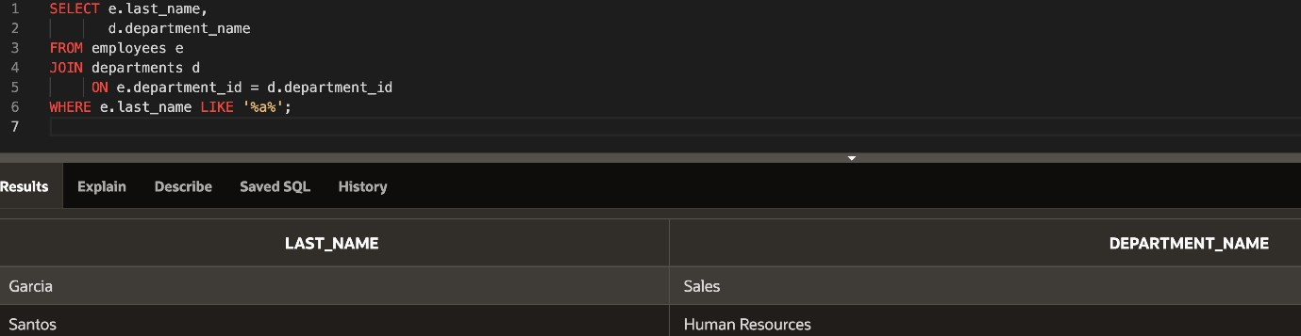

- Write a query to display the last name, job, department number, and department name for all
employees who work in Toronto.
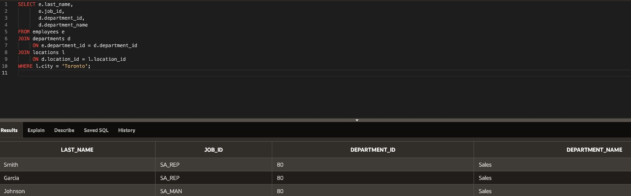
- Display the employee last name and employee number along with their manager’s last name and
manager number. Label the columns Employee, Emp#, Manager, and Mgr#, Respectively
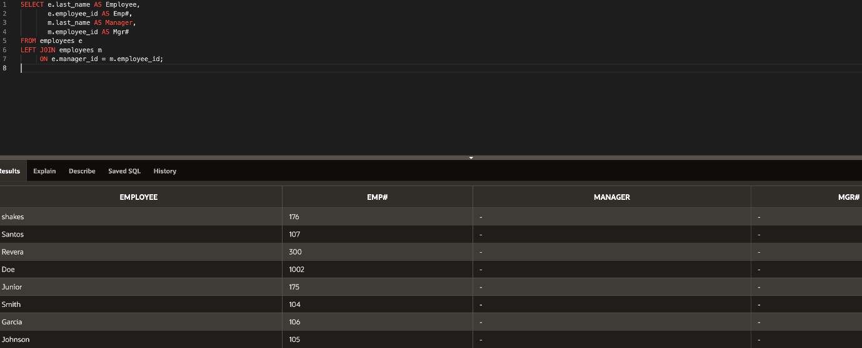
- Modify lab4_6.sql to display all employees including King, who has no manager. Order the results by the employee number.
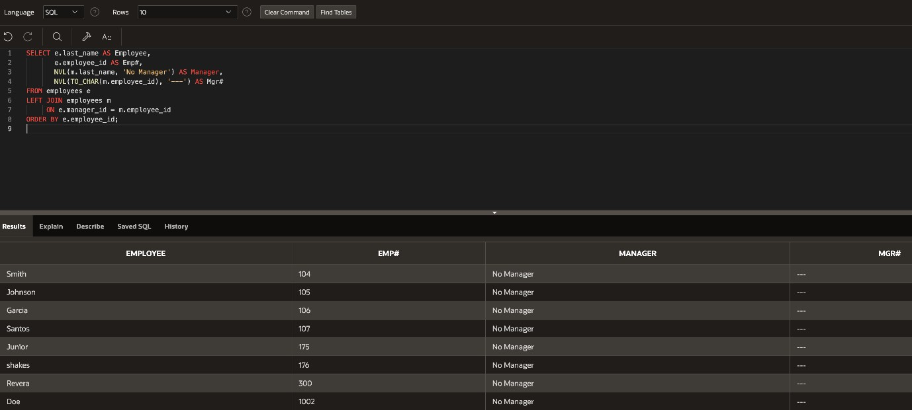
- Create a query that displays employee last names, department numbers, and all the employees who work in the same department as a given employee. Give each column an appropriate label
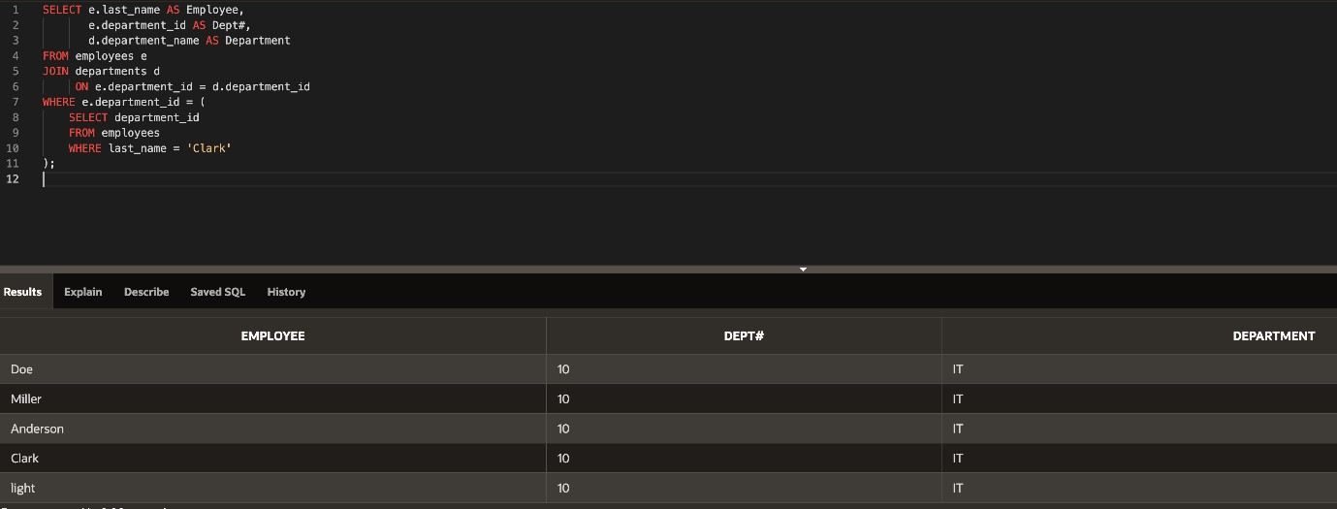
- Show the structure of the JOB_GRADES table. Create a query that displays the name, job, department name, salary, and grade for all employees
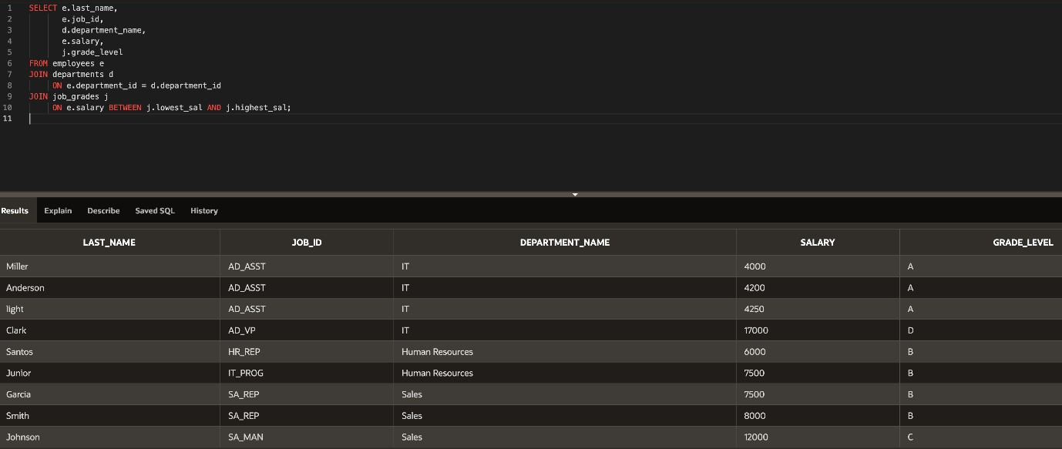
- Create a query to display the name and hire date of any employee hired after employee Davies.
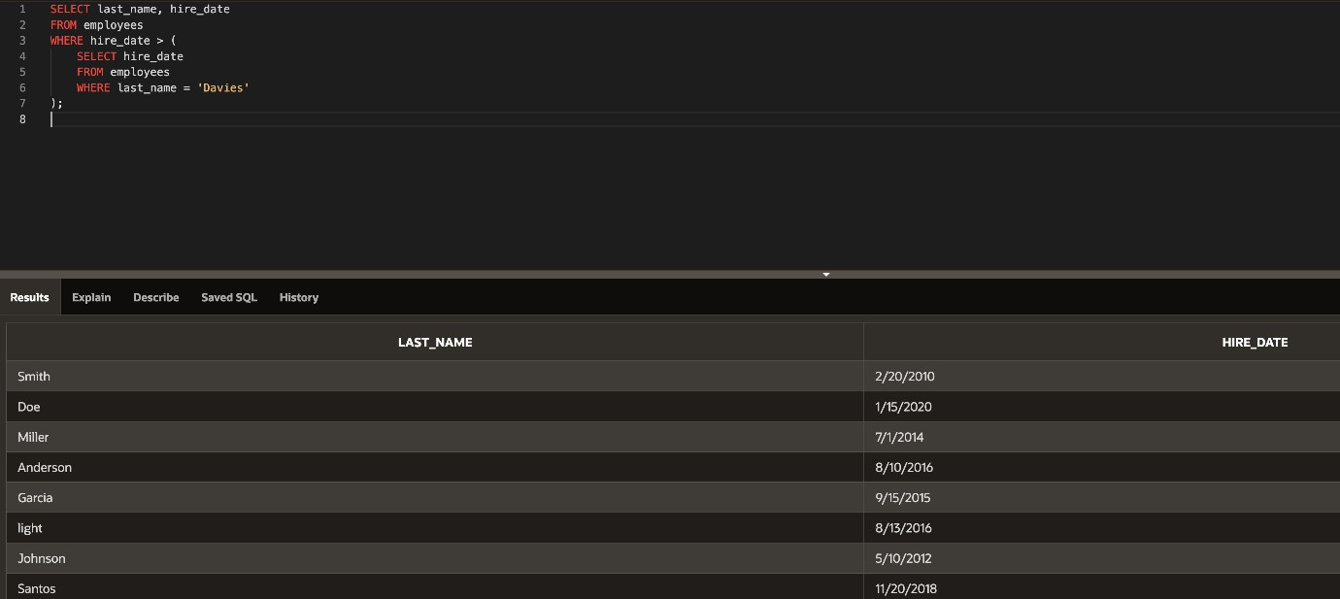
- Display the names and hire dates for all employees who were hired before their managers, along with their manager’s names and hire dates. Label the columns Employee, Emp Hired, Manager,
and Mgr Hired, respectively.
